What we been doing

What we going to do

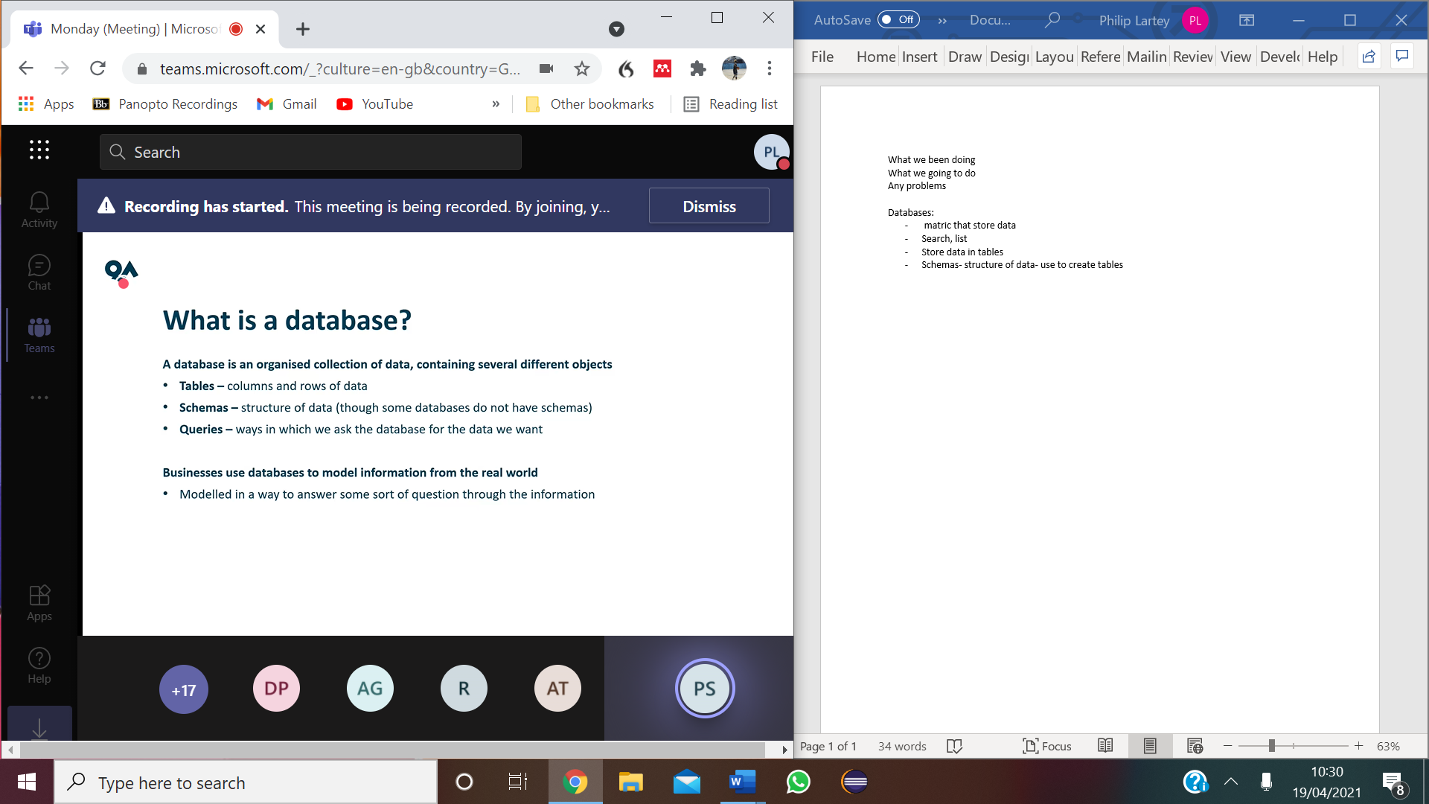Any problems

Databases:

* matric that store data
* Search, list
* Store data in tables
* Schemas-  structure and relationships between data. - use to create table
* Queries- (access data i.e search engine) select specific records within a database

Relational -SQL

Non-relational-

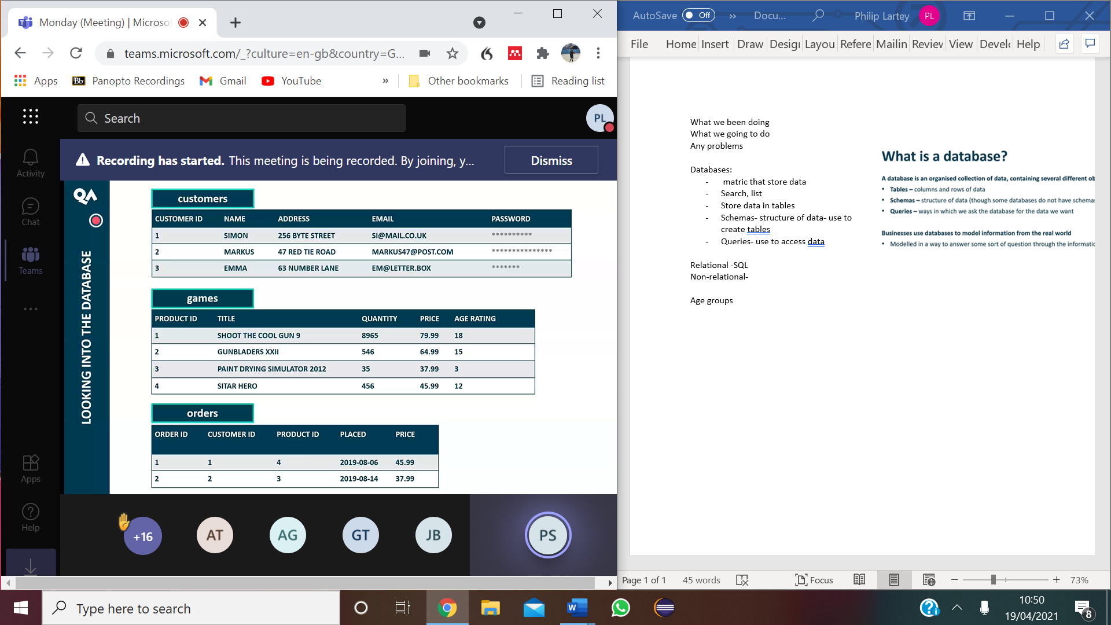

entities :Data stored in a database is organised into tables

Relational databases:

* modelling a business structure
* implementing strong business rules and constraints on data
* the type of information captured

i.e. MySQL, Oracle SQL, PostgreSQL, and Microsoft SQL Server.

Non-relational databases:

* focus on the read/write capacity and capability of data,
* Emphasising the speed in which we access data.

i.e. MongoDB, Amazon's DynamoDB, and Cassandra.

Database Objects:

Databases need to transform data into information by adding context.

* *Database* - a full data set, consisting of a collection of tables
* *Table* - an organised set of data objects
* *Field* - a way to categorise stored data
* *Record* - an instance of fields in a table

Relational databases run on relationships - a way of linking tables together.

CHAR: fixed character, only 6 characters i.e. passwords

VARchar: specify the number of unlimited characters that is accessible

Dec(4,2)

* 2 means the number of characters after the decimal
* 4 mean the number of characters

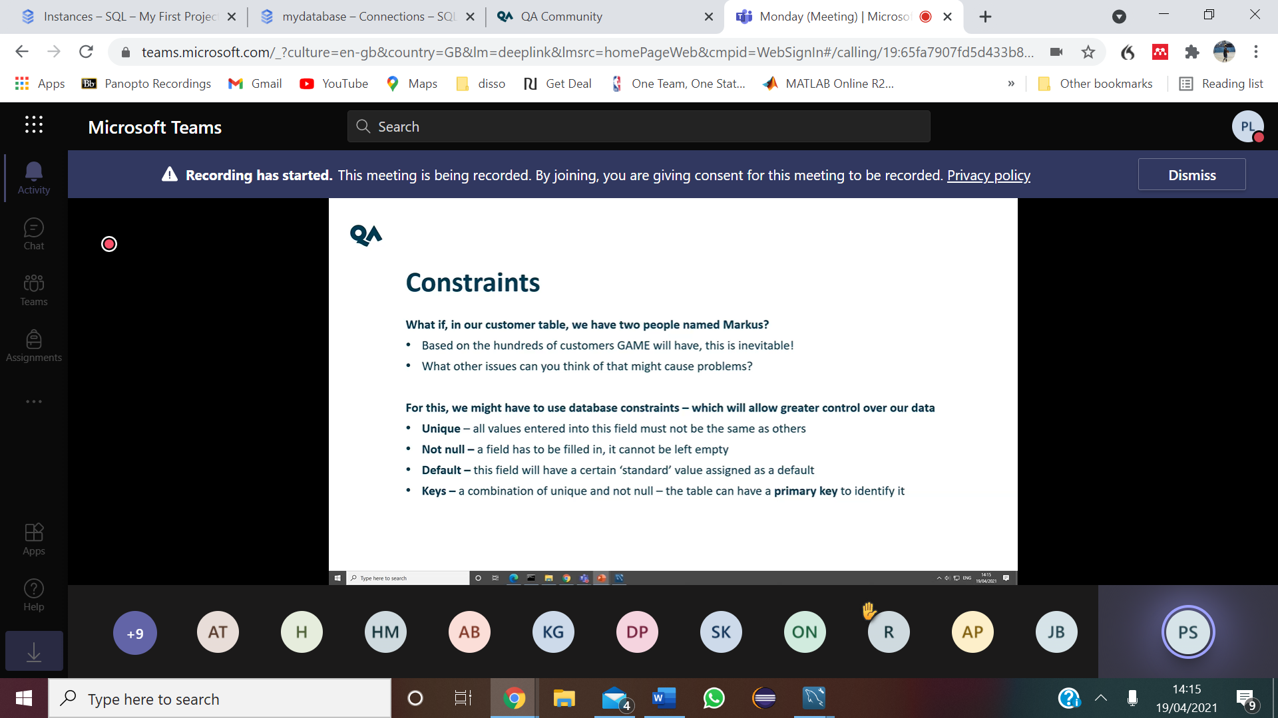

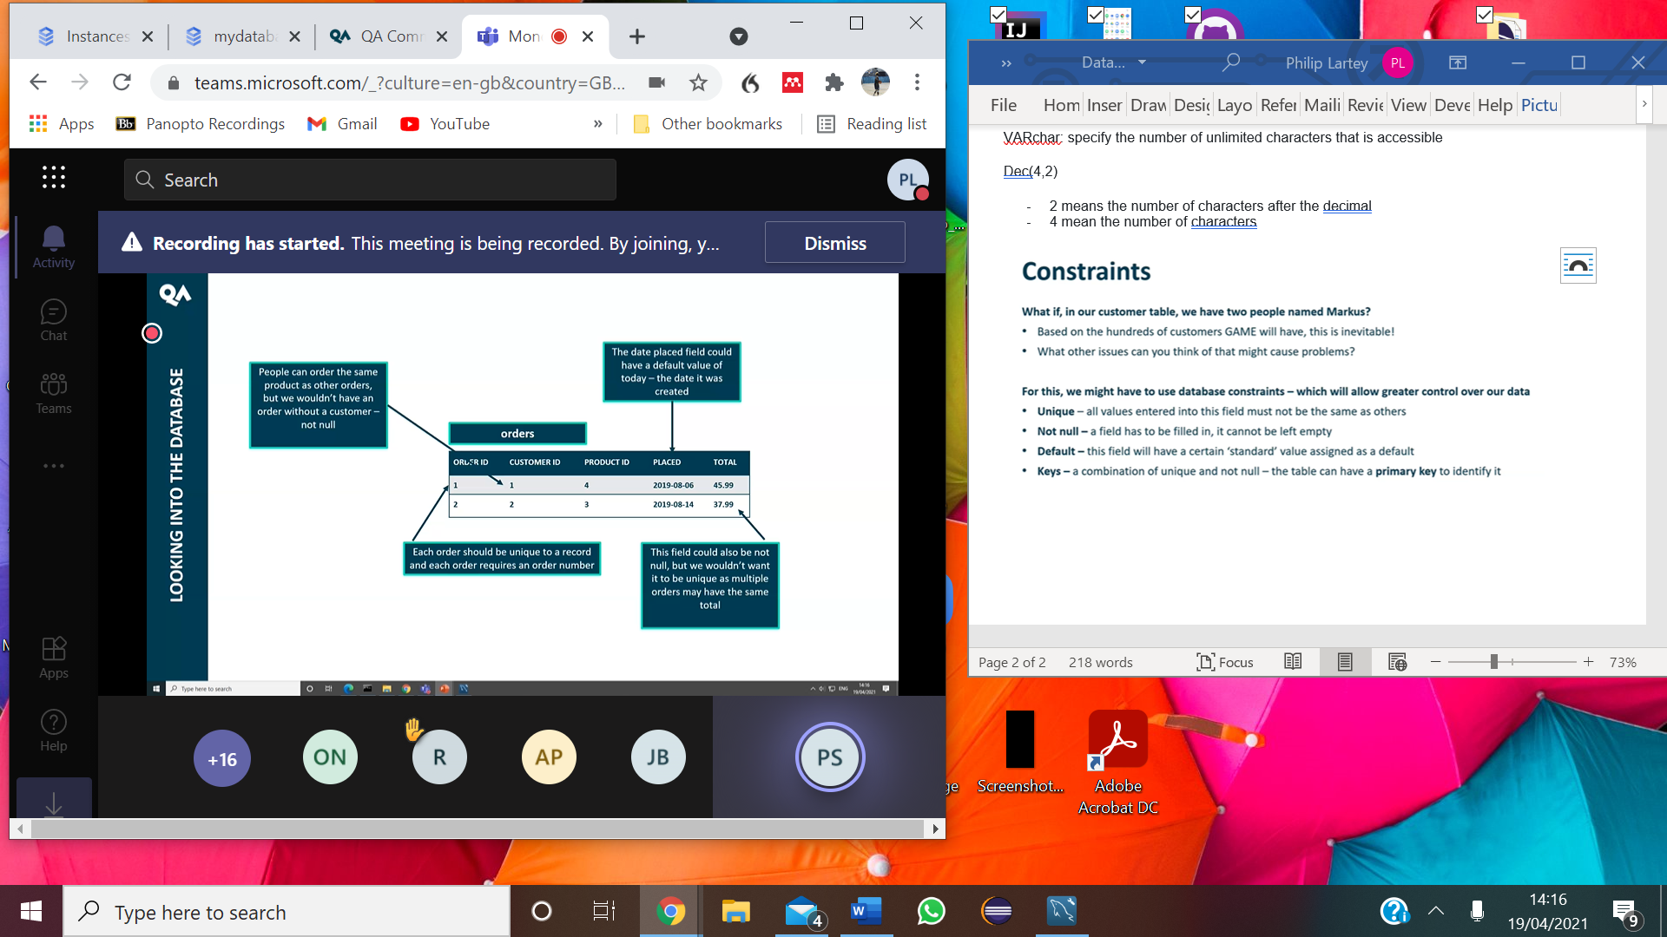

Other constraint:s

* auto increment
* Primary key: make each record unique
* I.e. Same name but the primary key will differentiate them both
* Foreign key: associate one table with another table
* i.e. push a customer table into an order table

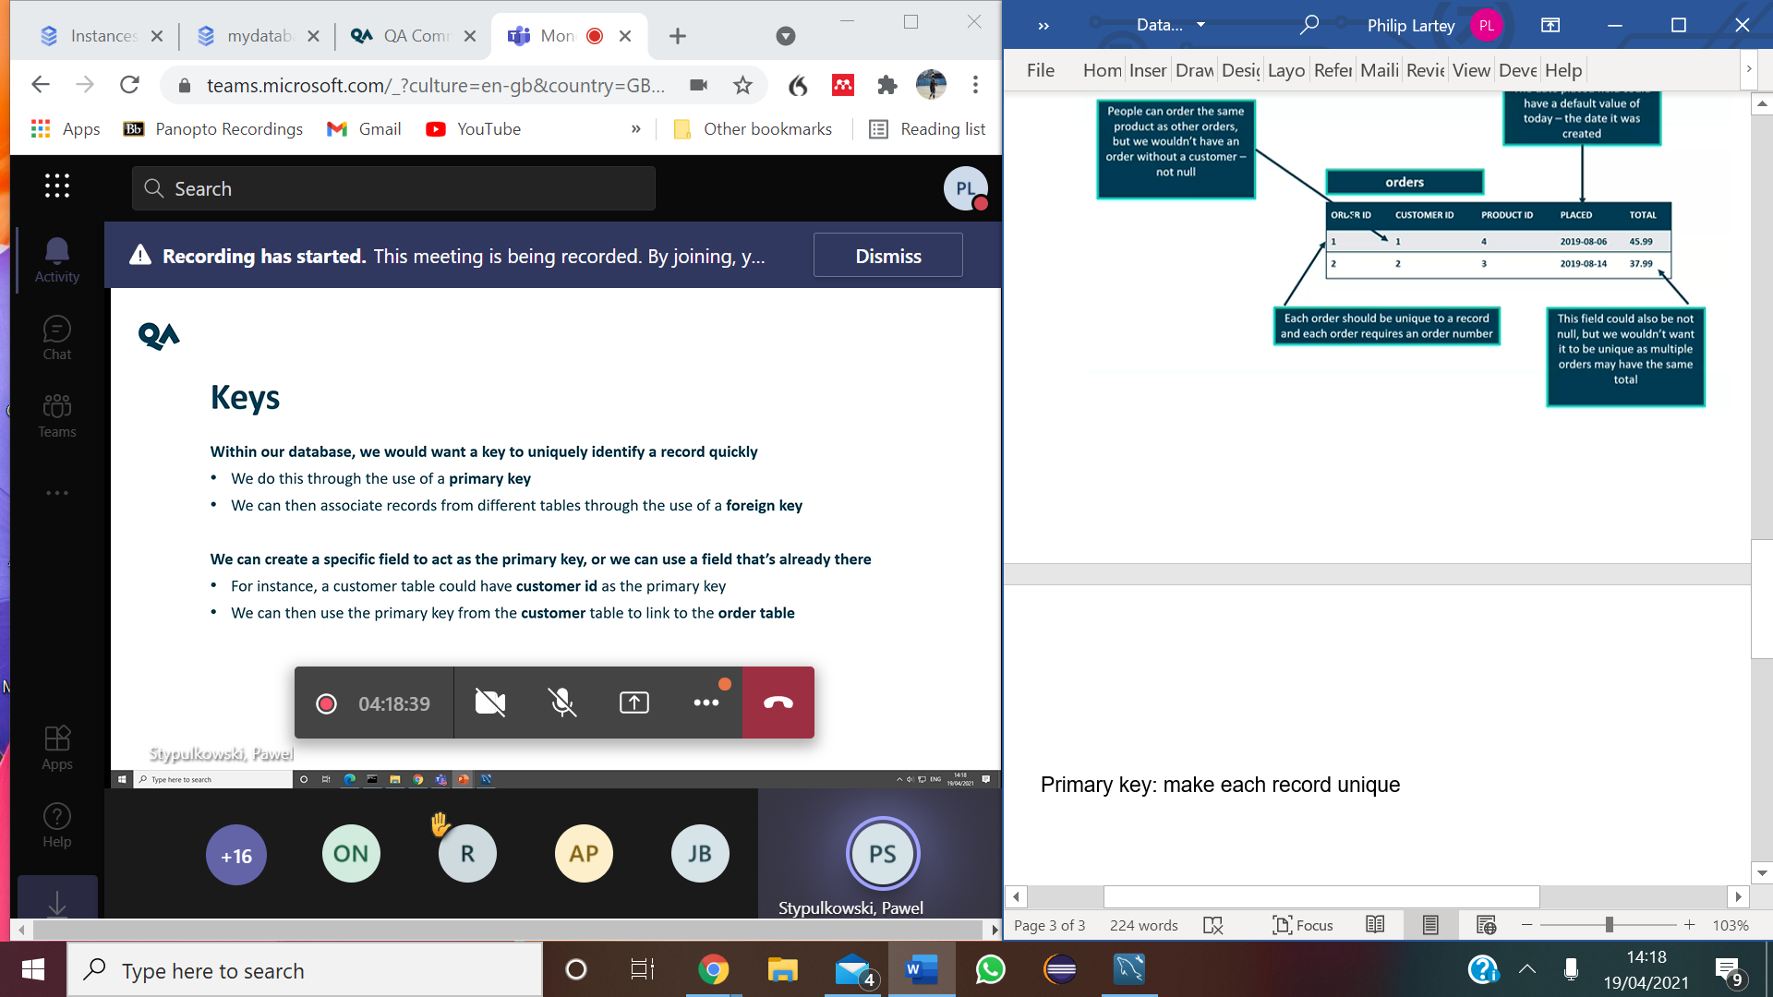

1. GCP- online server/database that stores data-base that is access to the community
2. Create a database
3. Create data in the database

* Tables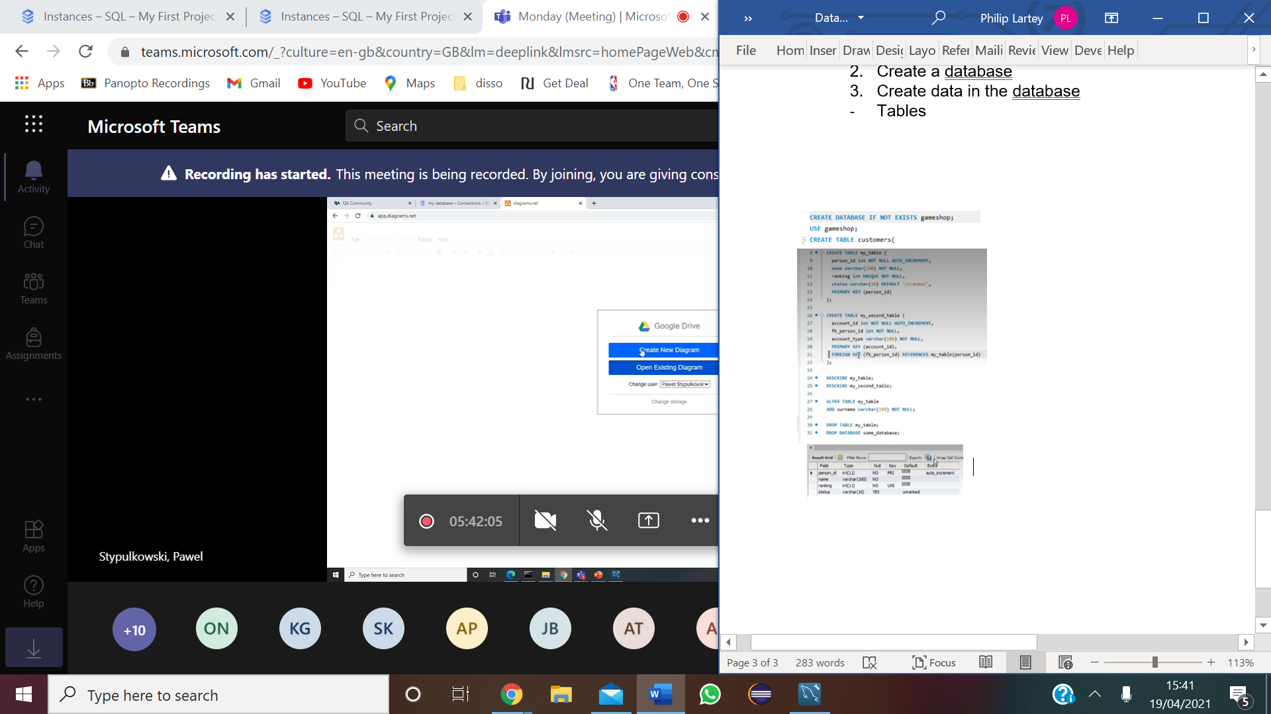

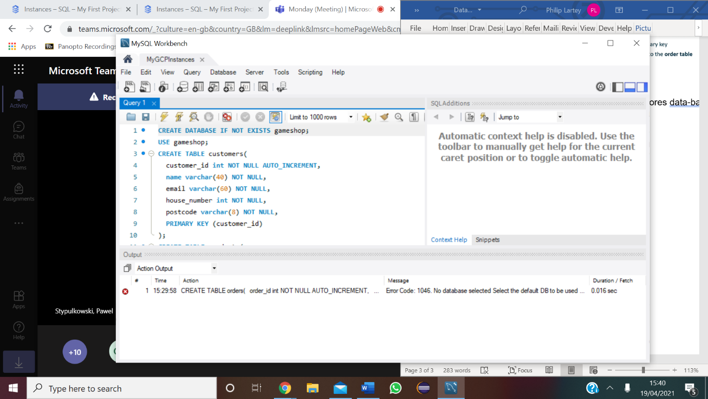

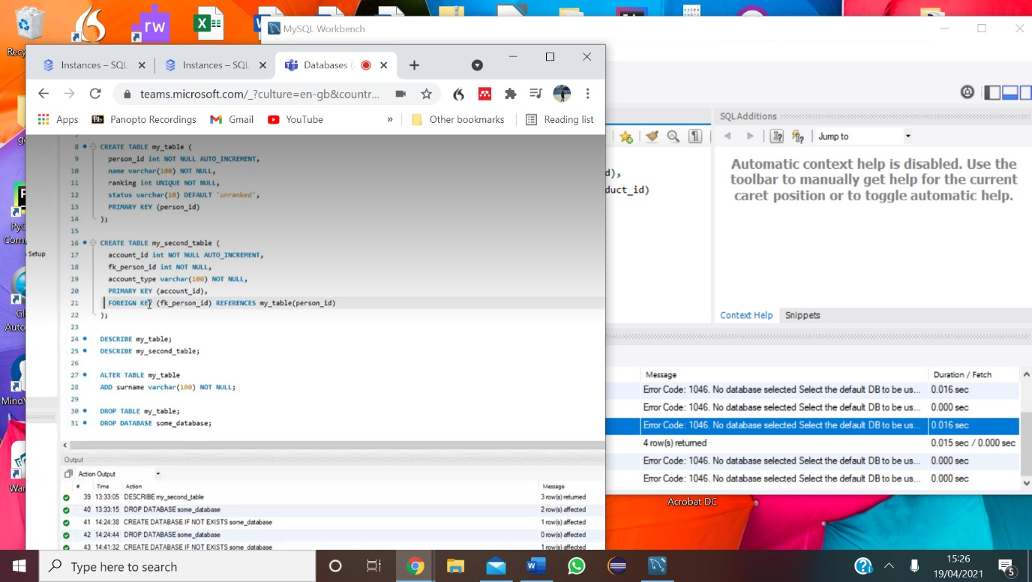

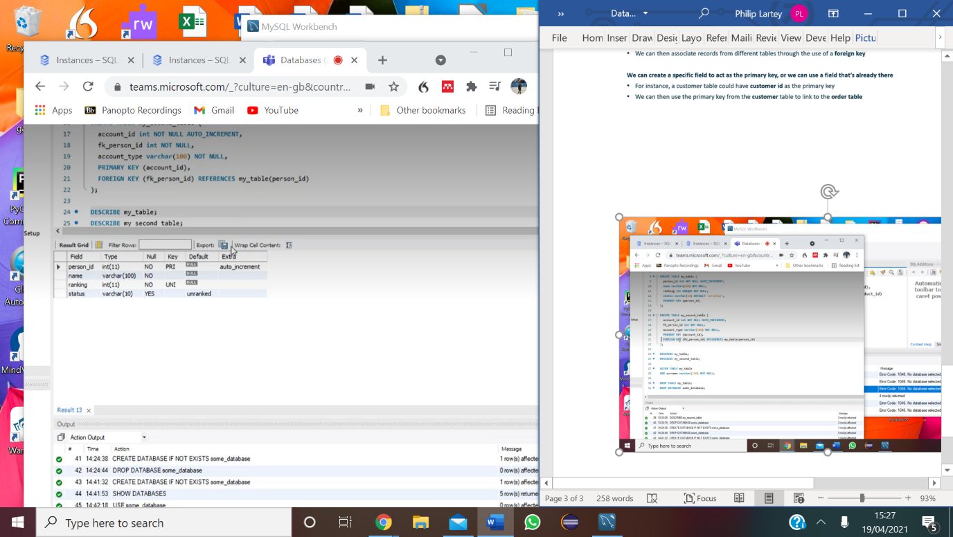

ERD (relationship )

* How tables relate to each other

Fk to PK- 1

PK to Fk= as many as you want

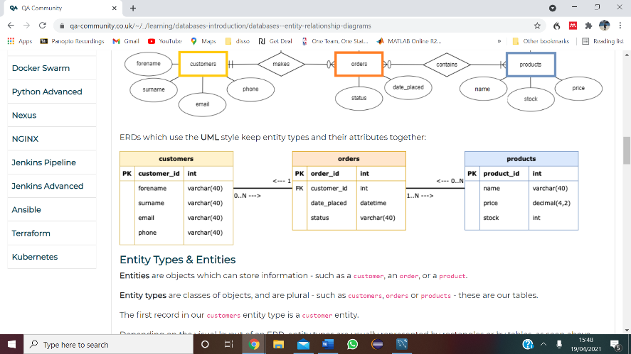 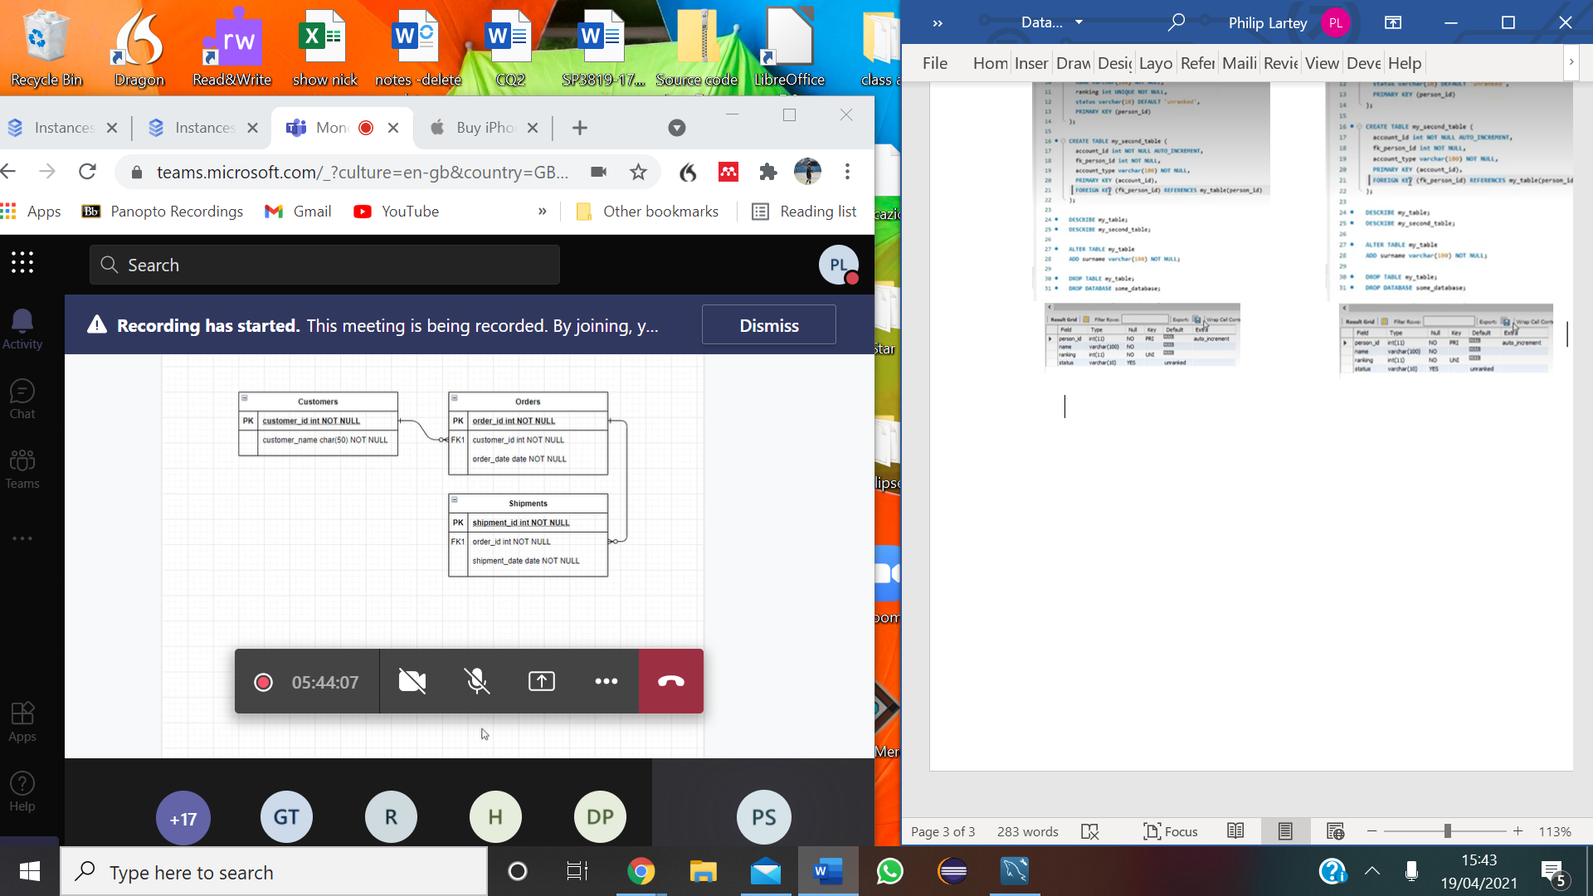

MySQL soes not support many to many relation

* Child table is created as a middle table
* to split the many to many relation into

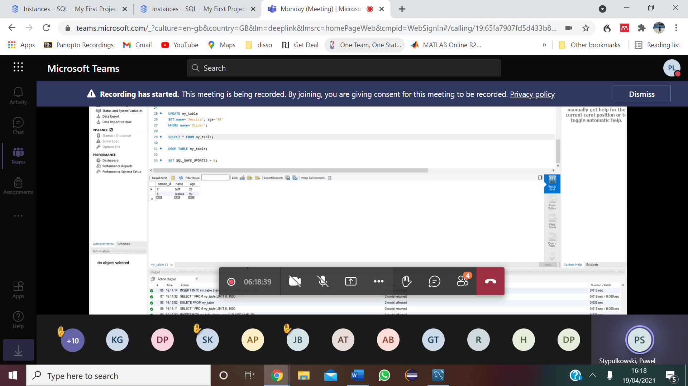

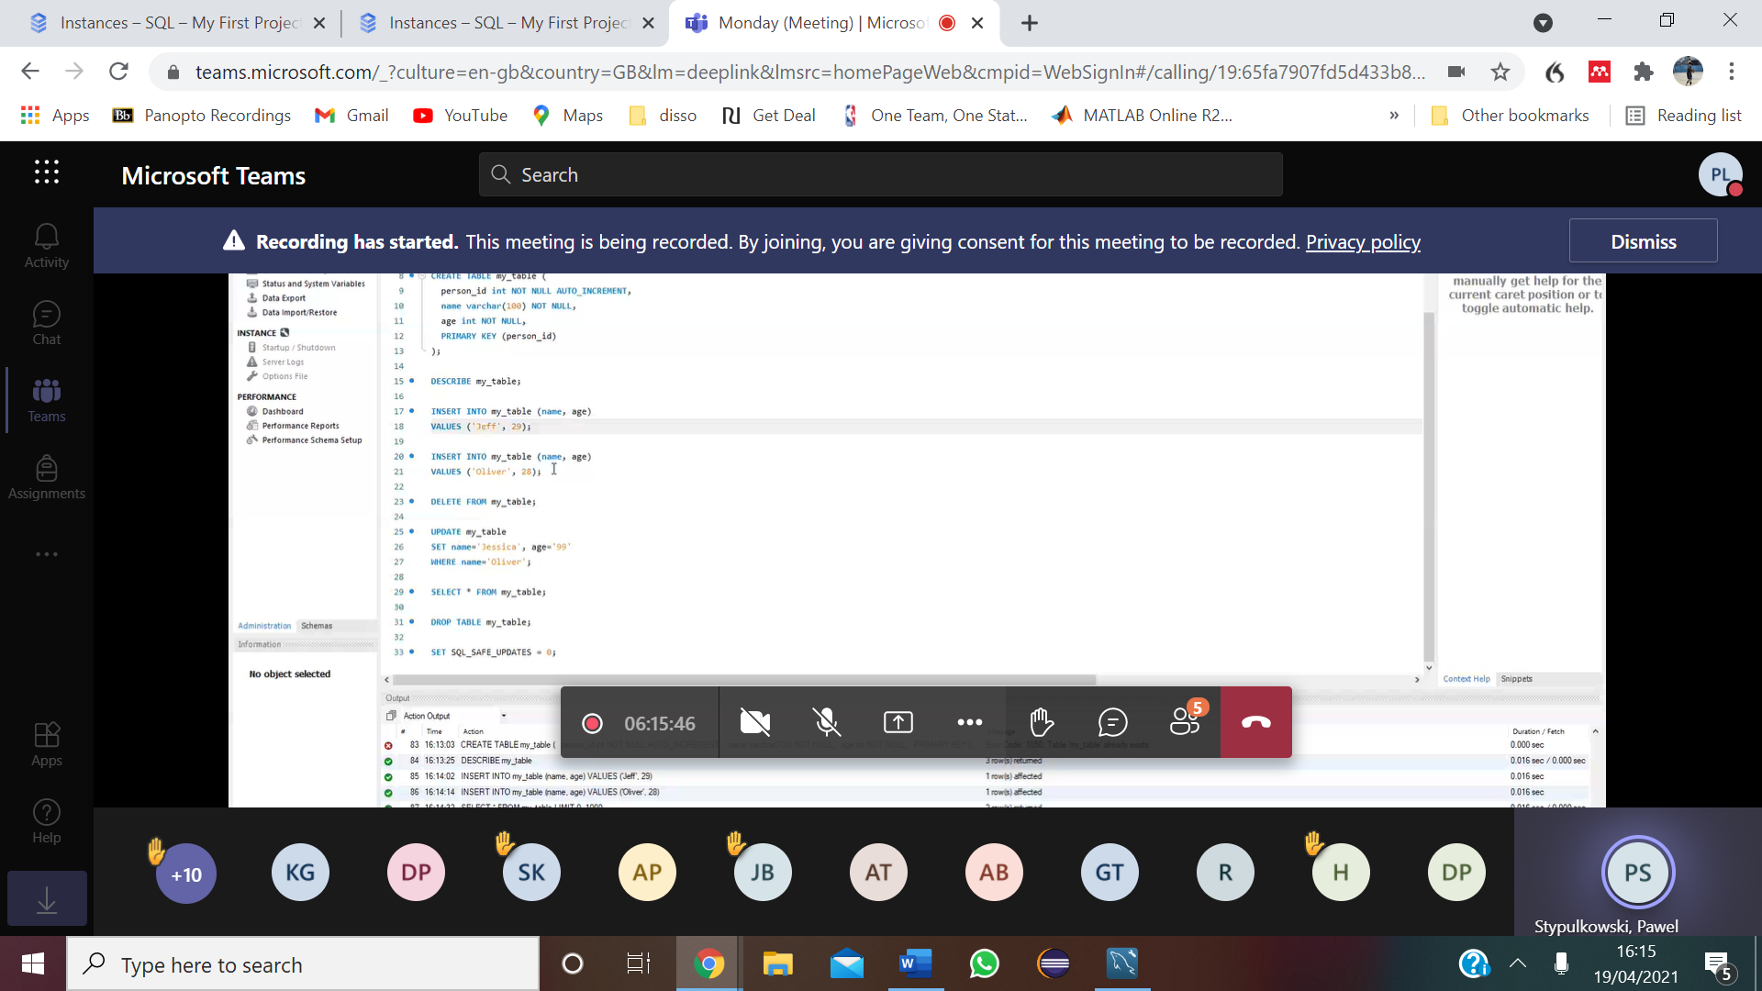

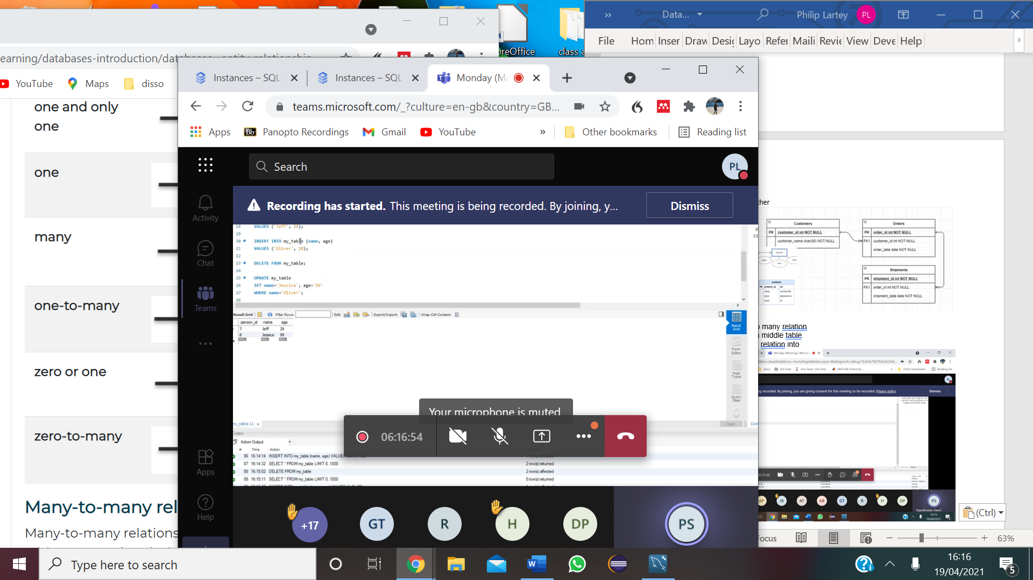

# DML

Describe shows field

MySQL Workbench

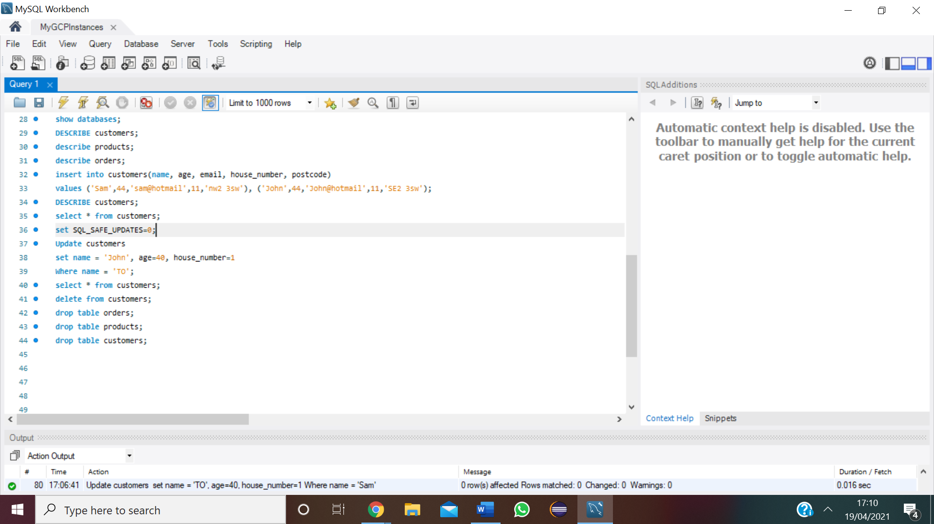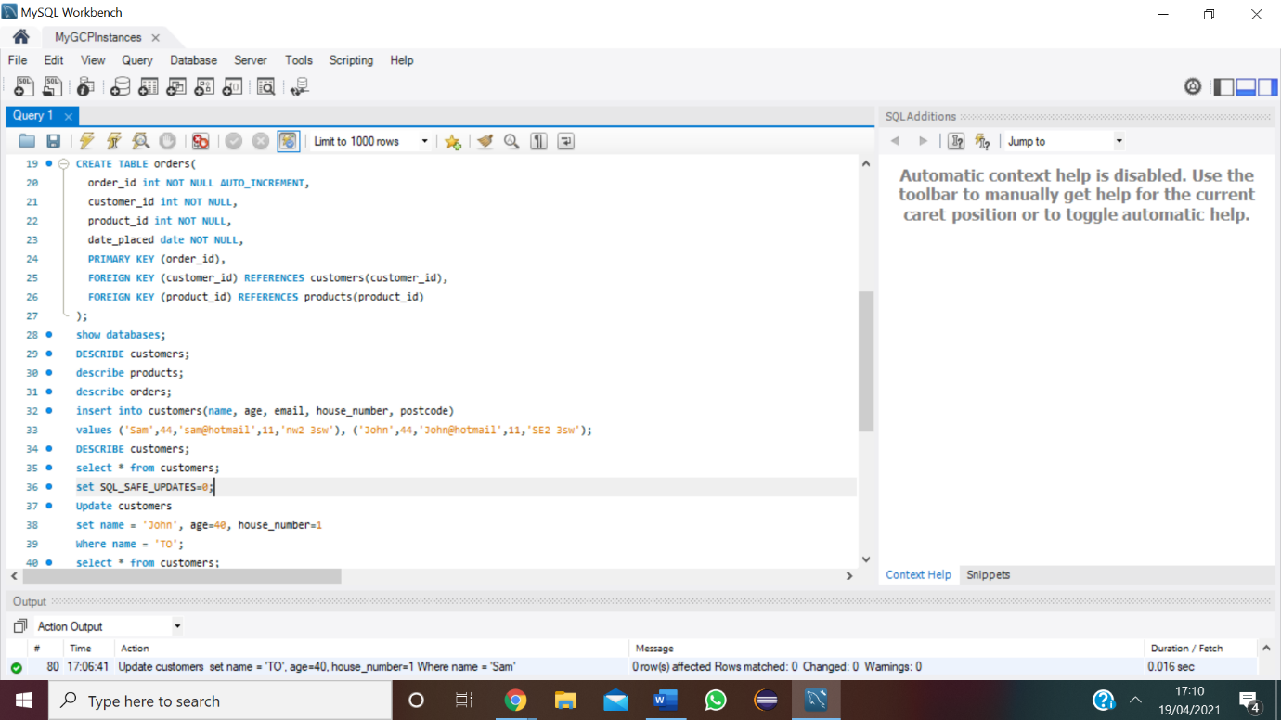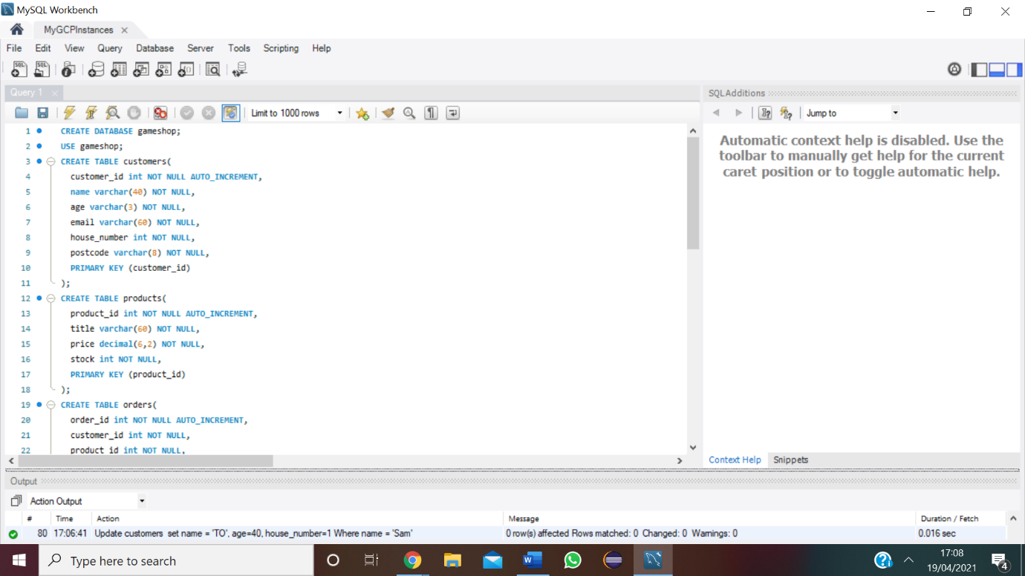

# Data Query Language using SELECTQueries ?

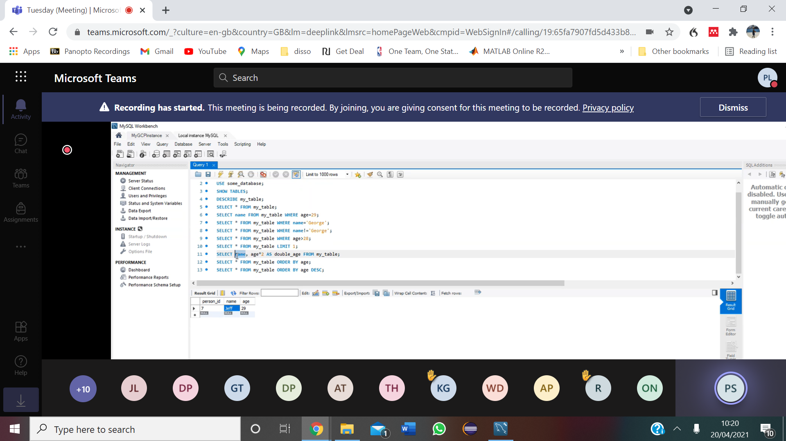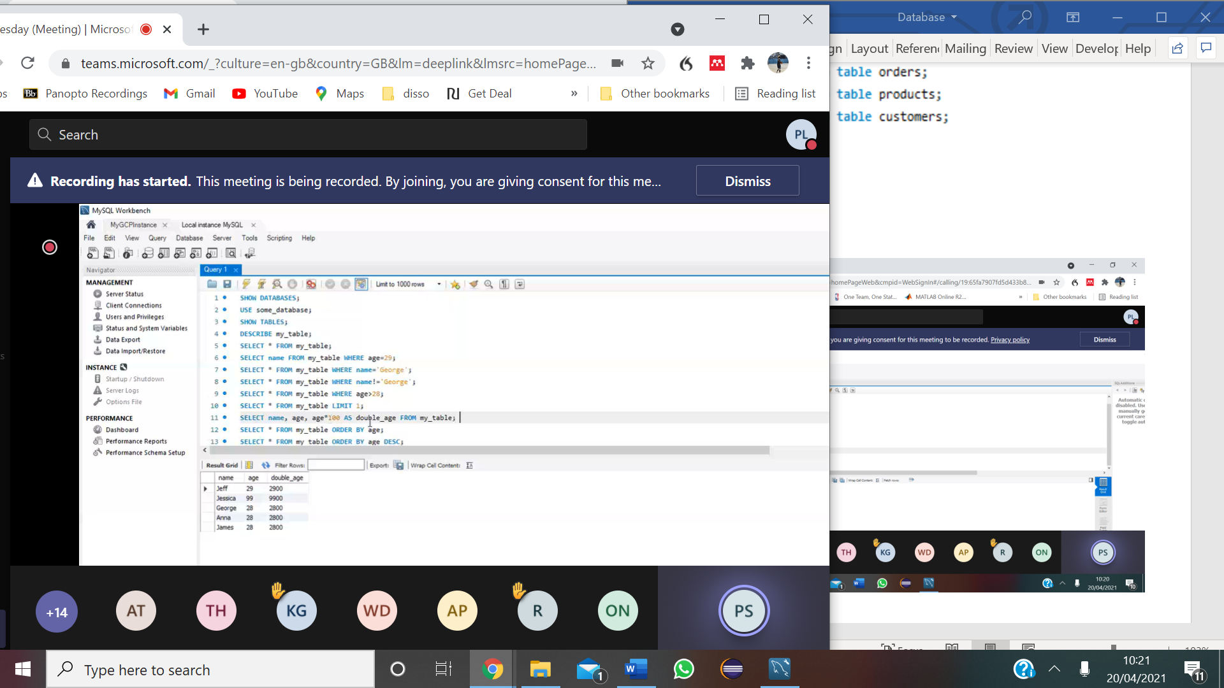**working with tables in Mysql workbench**

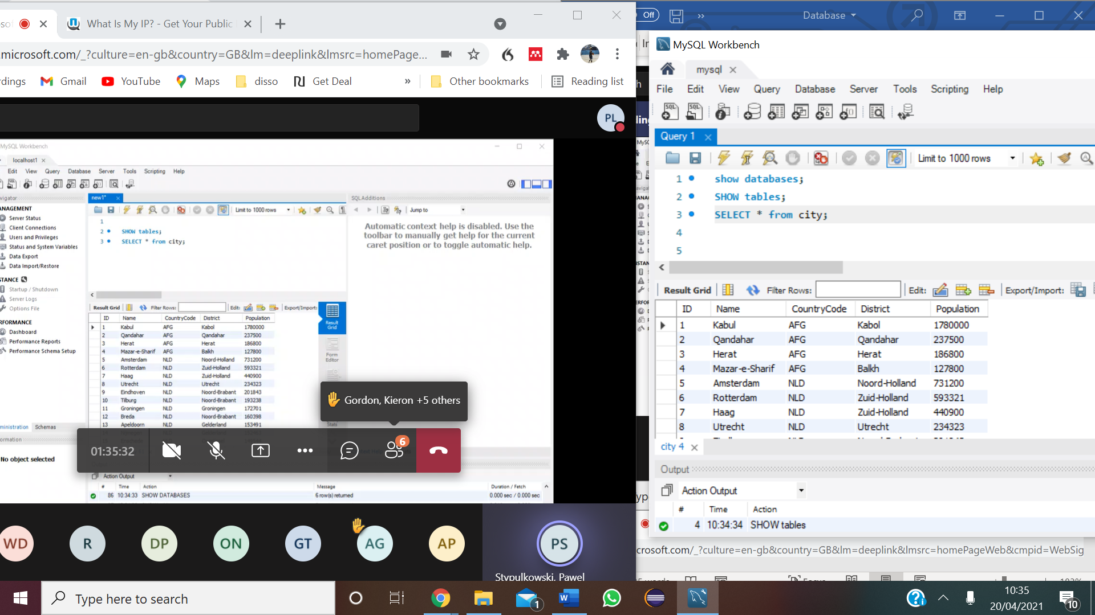

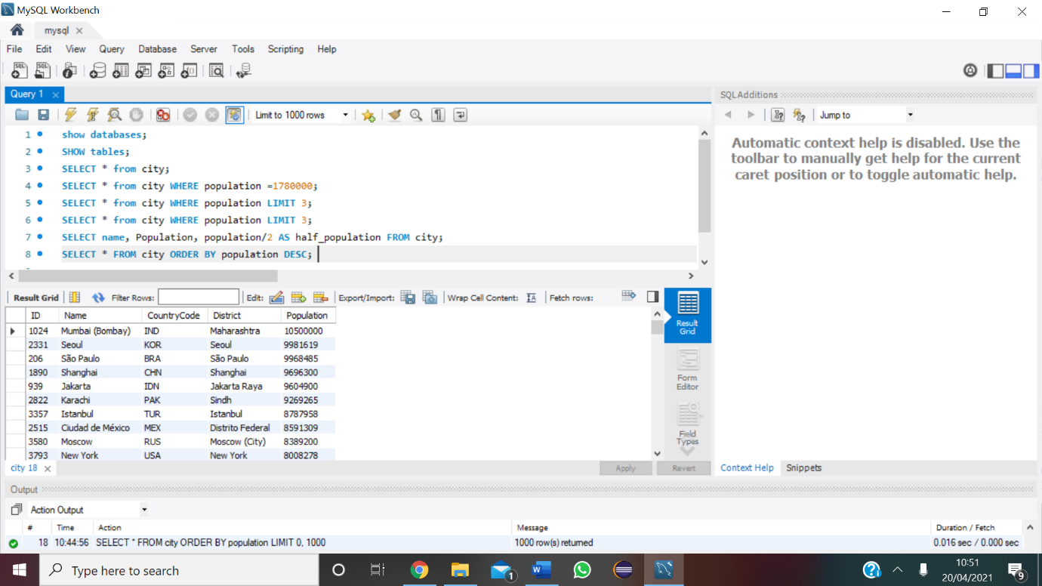

**Aggregate Functions**

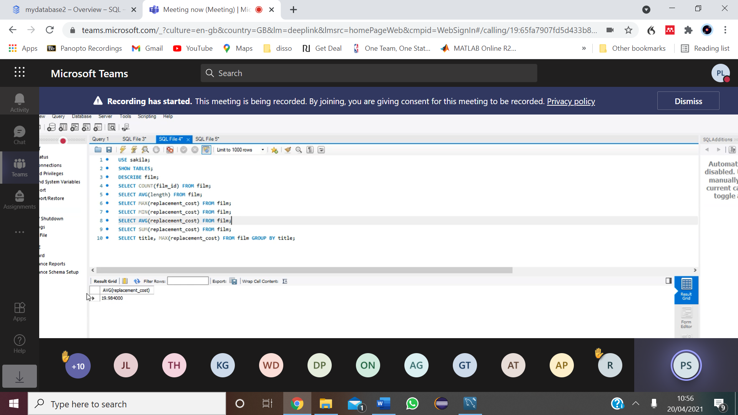**MIN, MAX, AVG,COUNT, GROUP the selected queries**

# Nested Queries

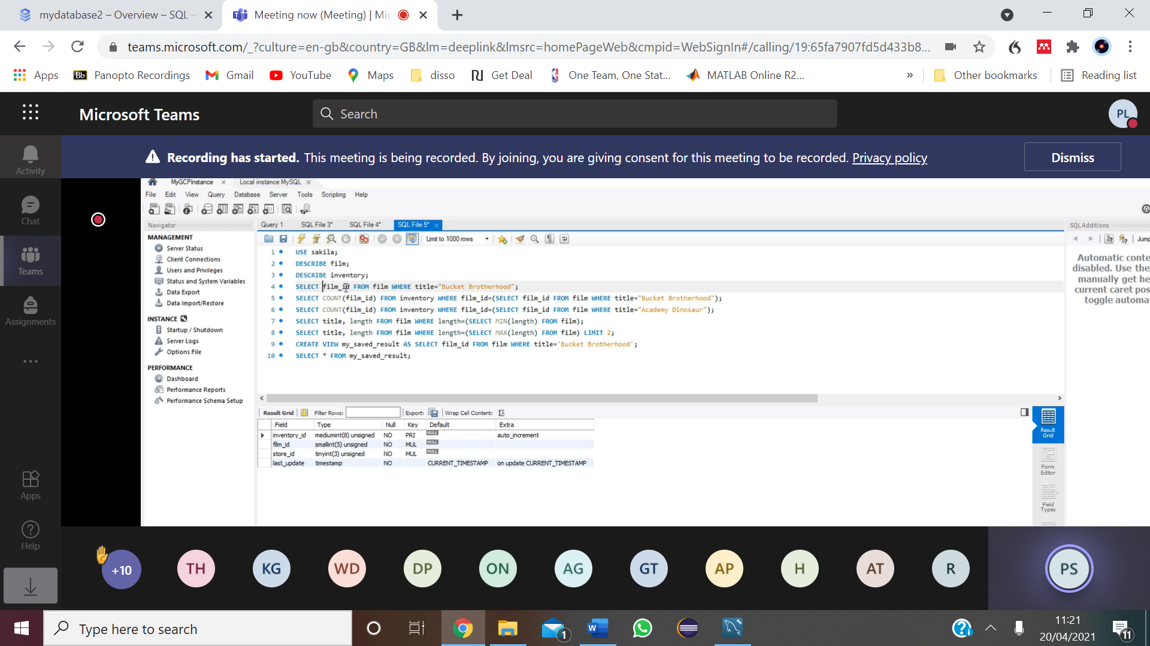**Select specific from tables, make queries permanent**

**make queries permanently added to the database (snapshot)**

* create new table called my_saves_result

# Joins

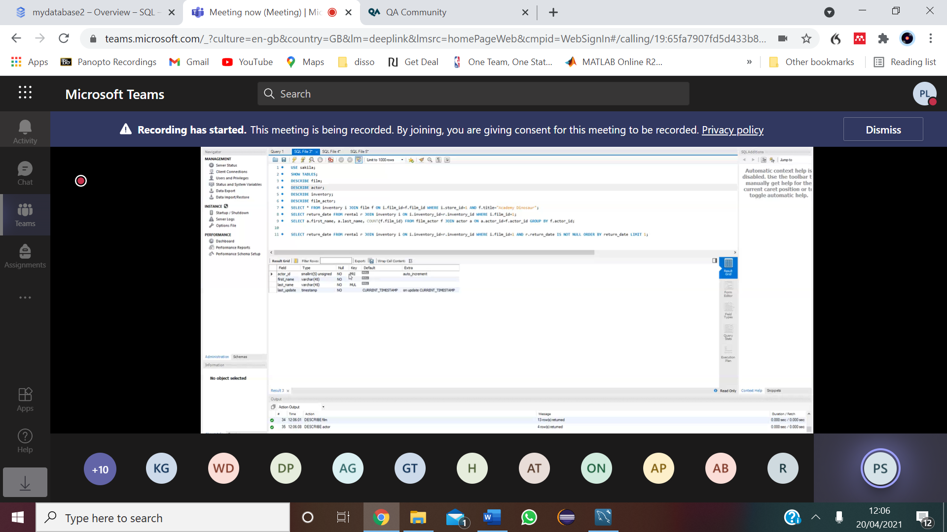

**Lesson Task**

1)Create a database for a school. It should include at least three tables - students, classes, enrolments

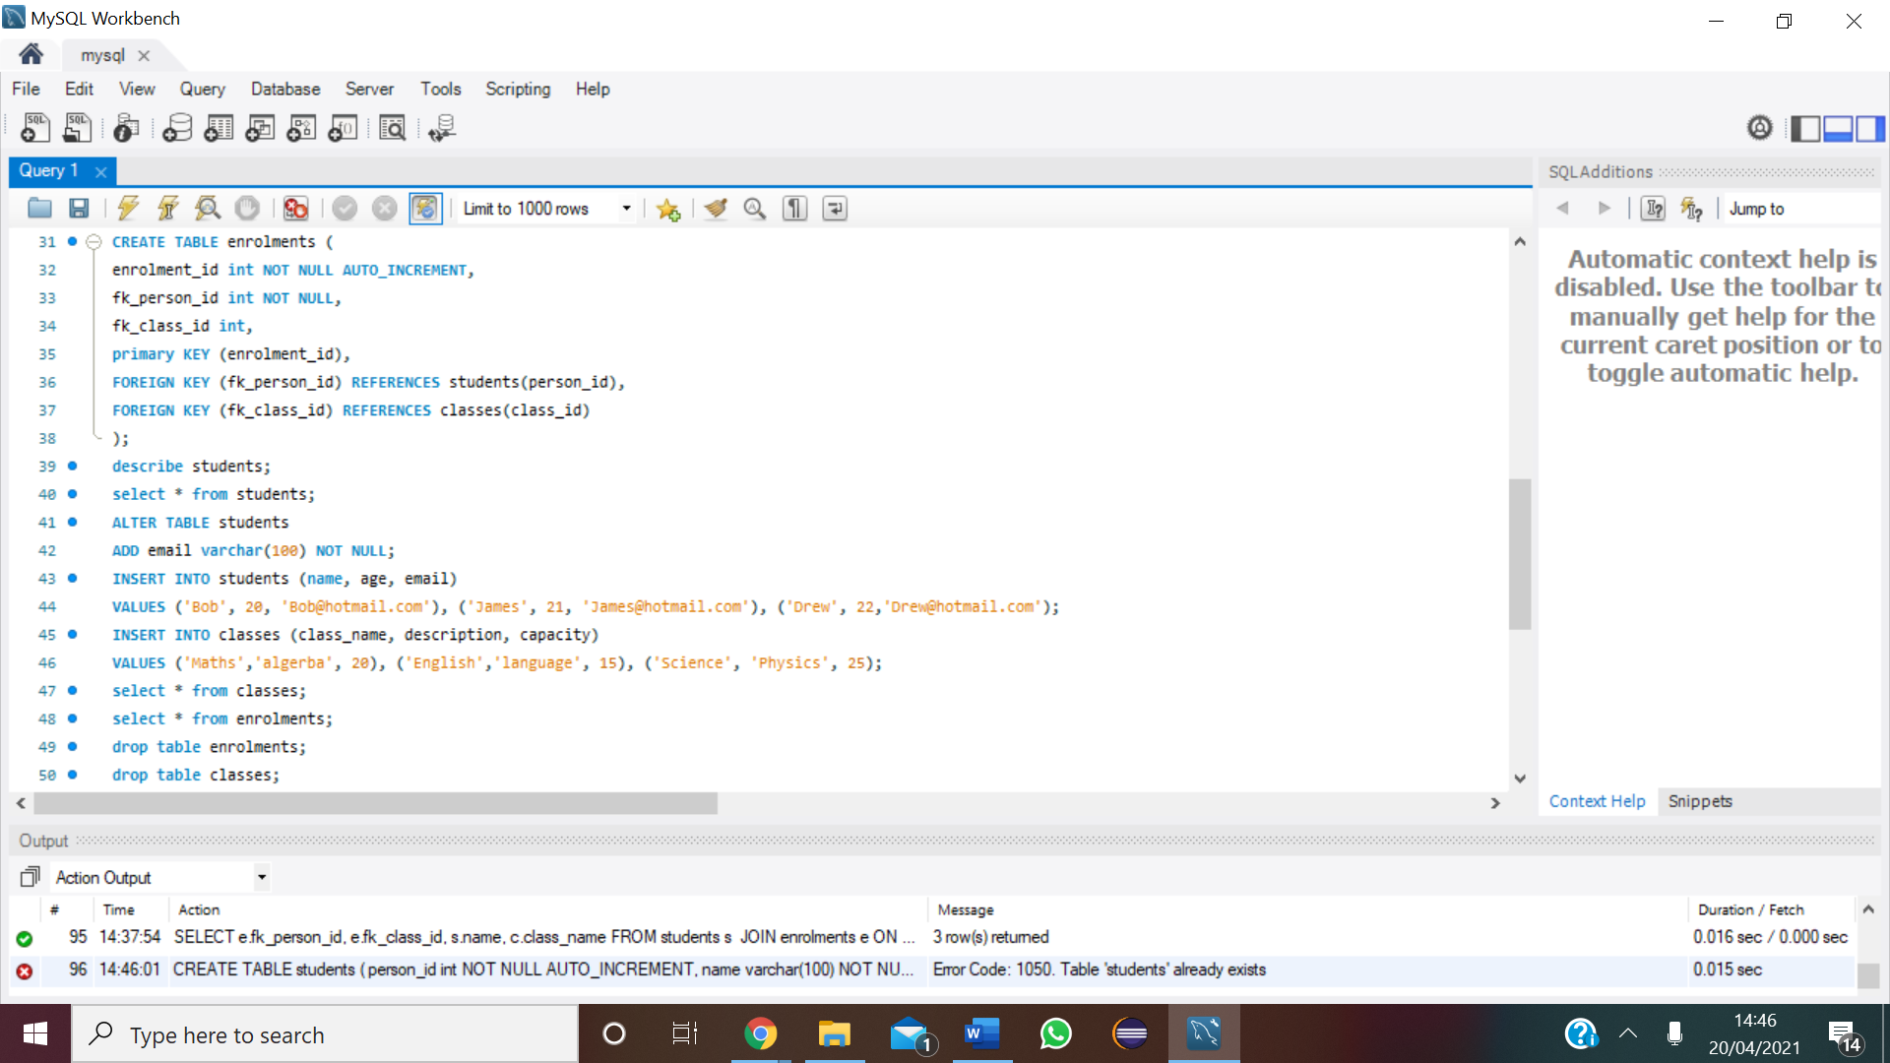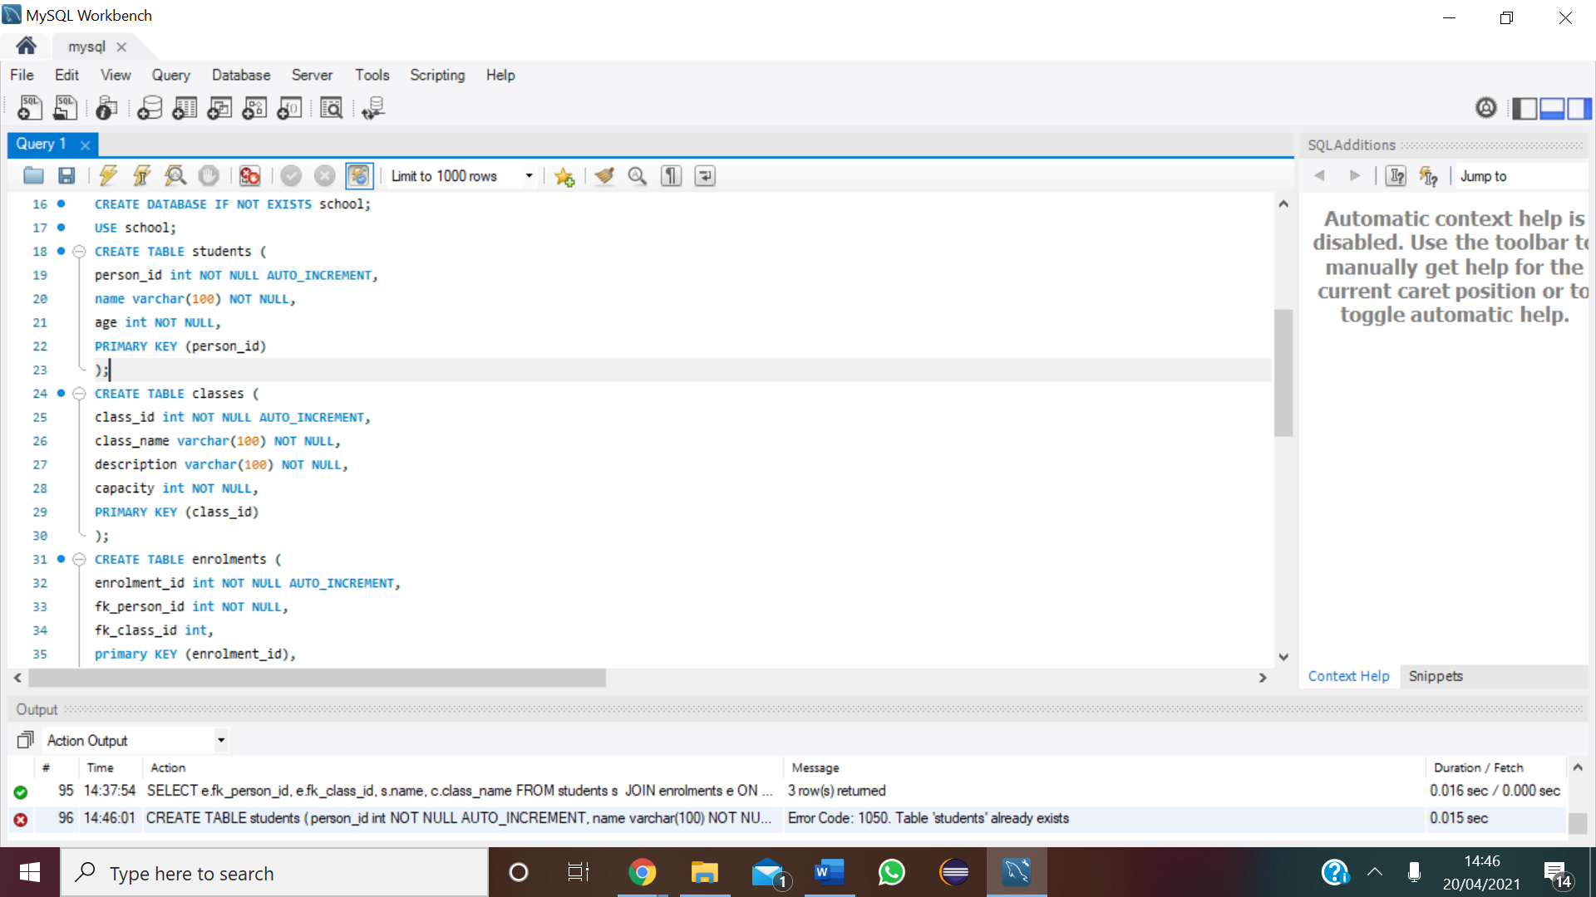

2) You should insert at least 3 students and classes into your tables.

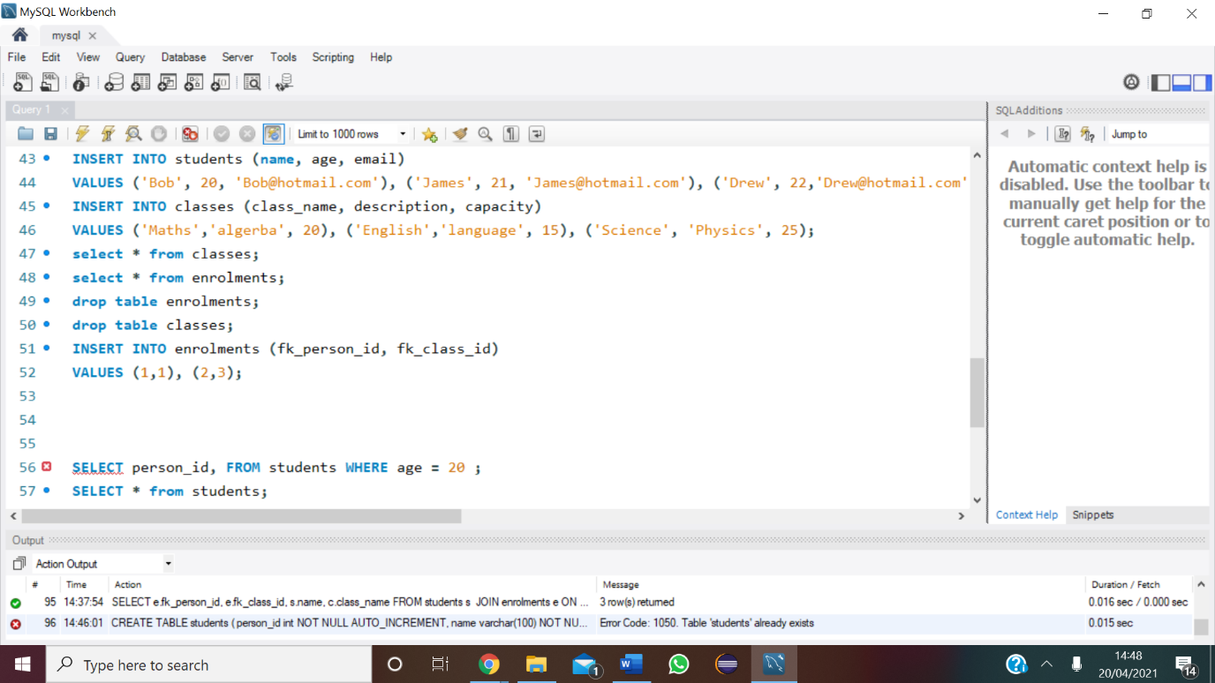

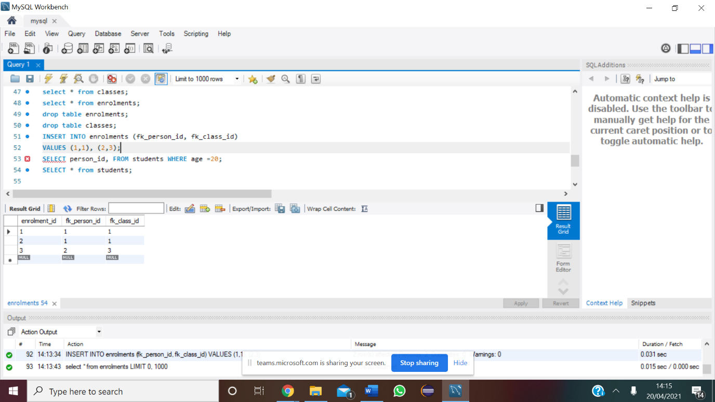

3) Each student should be enrolled in at least 2 classes.

- Many to many relationship (fk)

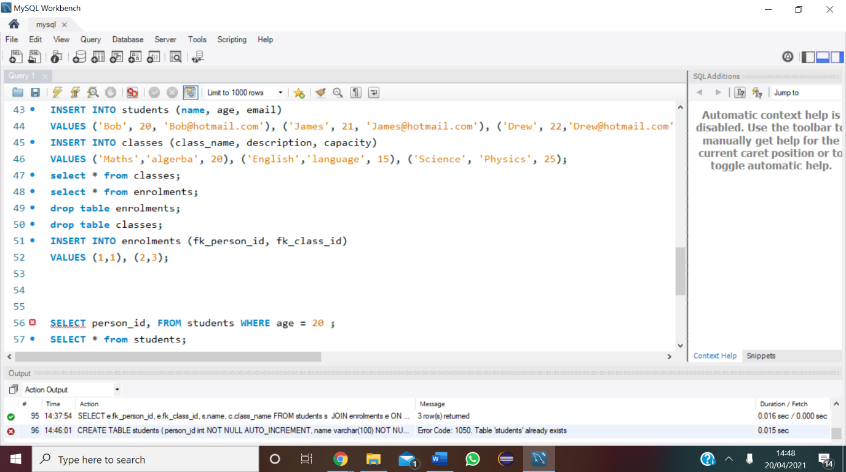

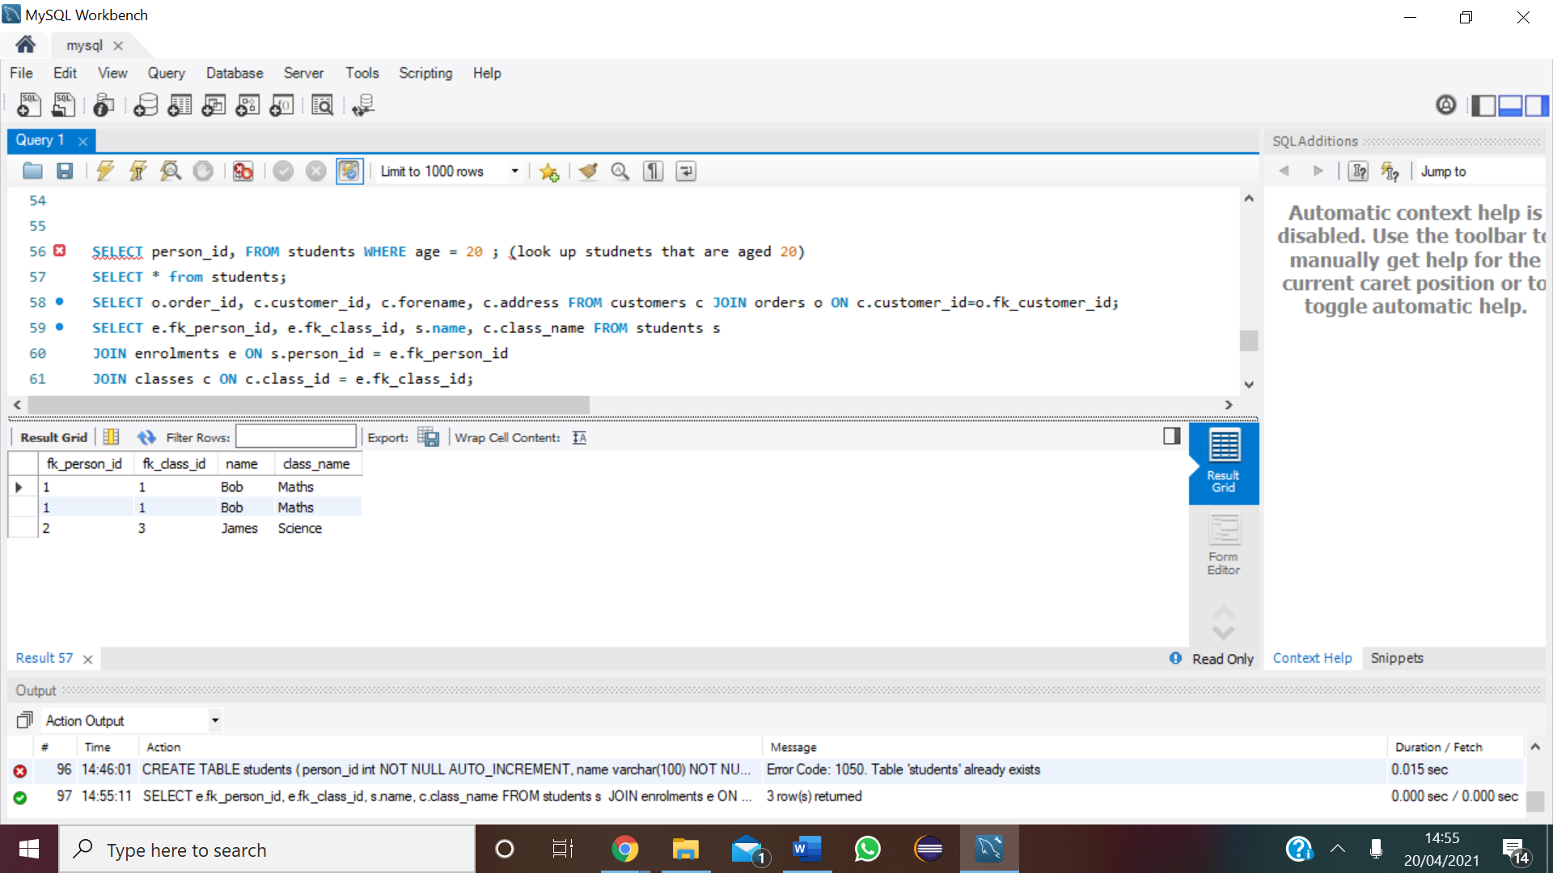4) Use joins/nested queries to find out which classes they should attend.

**Clearer syntax**

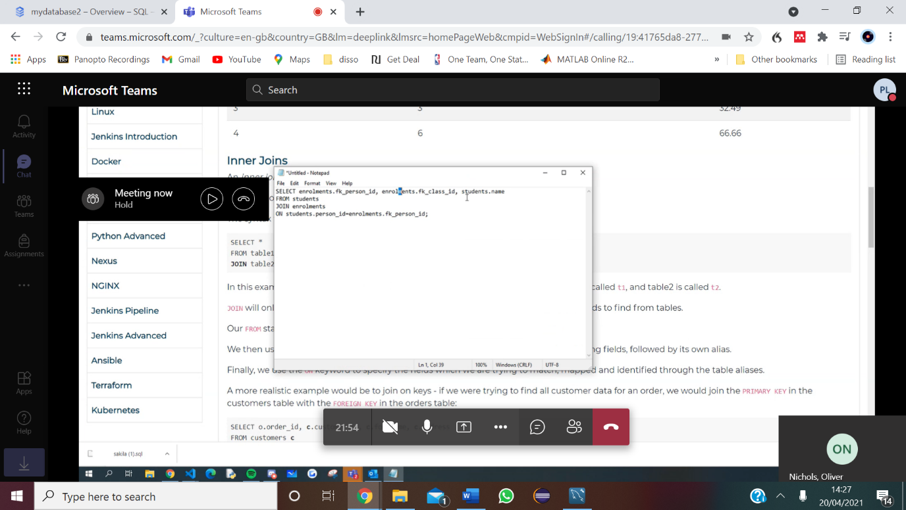

Task

1. 274
2. LE= 75.1, 37032000

DELETE

